It is a battle for the Thone of Westeros!!! The two most powerful families are going head to head in a fight for power and honor. House Lannister of Casterly Rock is one of the Great Houses of Westeros one of its richest and most powerful families and oldest dynasties. House Stark of Winterfell is an exiled Great House of Westeros, ruling over the vast region known as the North from their seat in Winterfell. George R. R. Martin wants your help in making a hero but different a hero's attributes depend on which house he represents. Attributes contribute to how much land he will have in his kingdom in square miles which represents how powerful he is.
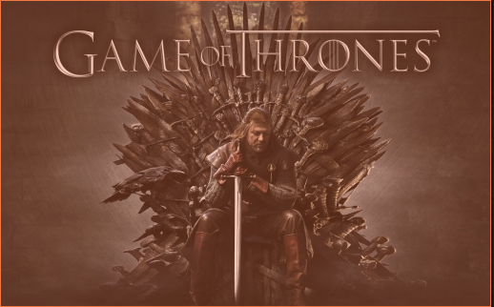

Advantages of being born into a Great House:
From House Stark: 500 sq miles
From House Lannister: 300 sq miles

Attributes each hero can have:
Bravery: Add 30 sq miles
Honesty: subtract 10 sq miles
Honor: Add 10 sq miles
Ruthlessness: Add 40 square miles
Strength: Add 50 sq miles

Assignment 1: Implement a software system allows you to calculate the amount of land a hero is given by birth plus any attributes he/she attains over their life. The system must be exhibit extendability in that if other attributes affect the hero's land gains or losses they can be easily added. Use the decorator pattern to implement this software.

Assignment 2: Draw a UML diagram to represent your solution.

